
https://atlas.cid.harvard.edu/

Optimal Industry Development Strategy Using Economic and Product Complexity

Norway

─
The Economic Complexity Lab - Columbia University
Alexandra Garcia, Kelly Mi, Margarita Demkina, Allison Lin, Helena Yang, Jane Zhang, Daniel Xu, Ryo Shibata, Haoxian Chen, Davepriyan Gunaratnam, Rohan Macherla, Ajit Akole, Shomik Ghose, Alex Wei-Liang Ku, Sannidhya Modi, Xilin Wang

Optimal Industry Development Strategy for Norway

0. Executive Summary

In this report, we uncover the economic path Norway went through during the period from 2013 to 2018. Specifically, we dive into the topic through a macroeconomic overview of Norway from the perspective of Gross Domestic Product (GDP) and Economic Complexity Index (ECI), which reflect countries’ production capability and production structure, respectively. We find that during the period of our interest, Norway demonstrated a low level of economic growth with an average annual GDP growth rate of 0.54% between 2013 and 2018, concurrent with a decrease in economic complexity as compared with other similar major developed economies, and 7.55% between 2019 and 2021, with a increased economic complexity compared to other major developed economies.

The negative progress from 2013-2018 and positive progress through 2021 can be partially explained through analysis of the economic complexity structure of Norway on the industry group level. The product classification system we adopt allows us to measure the realized development for various industry groups. We observe that Norway consistently relied on developing the Transportation industry from 2013-2018 and Precious Stones in 2019-2021, while its developed counterparts and emerging economies around the globe have adopted much similar paths.

Based on our analysis of the opportunity gain and a sensitivity analysis of major industry groups, Norway can further its gains by prioritizing Machinery and Construction and Daily Instrumments in 2018. Three years later, in 2021, its focus should have shifted to Vegetables, Fruits, and Plants and Precious Stones, which have lower-complexity due to the shocks of the pandemic. We further note that Norway has a slightly mismatched development strategy that indicates a moderately high (compared to other developed countries) level of structural optimality on the complexity level, having an adjusted R-square of around 19.5% in 2018 and 4.38% in 2021. A significant positive correlation exists between five-year GDP growth and the structural optimality index of an economy as we define and calculate, but Norway, continued to have significant growth as compared with fast-growing economies both on a regional scale and on a global scale. However, the country has the potential to further its economic gains through industrial structure optimization as suggested in the paper.

1. Report Overview

We aim to uncover the economic path Norway went through during the period from 2019 to 2021, before and after the COVID pandemic, compared to its performance from 2013 to 2018. Specifically, we dive into the topic through a macroeconomic overview of Norway from the perspective of Gross Domestic Product (GDP) and Economic Complexity Index (ECI), which reflect countries’ production capability and production structure, respectively. We then analyze the industrial framework of Norway during the period based on quantitative measures such as Product Complexity Index (PCI) and Product Family Complexity Index (PfCI), followed by a detailed analysis of how changes to this framework have matched with development strategies as quantitatively measured by opportunity gains on an industry-level. We conclude our report with macro-level results and predictions of Norway, as deduced from regression models we have established on a global scale, which take into account countries’ stances in their product space.

2. Macroeconomic Results

2.1 GDP Ranking and Changes
Figure 1a illustrates the time-series GDP results for Norway and three of its peer countries (Finland, Sweden, and Denmark) from 2013-2018. In contrast to the other countries, which generally displayed either constant or upwards growth over all years, Norway had a noticeable dip in GDP from 2014-2015. Additionally, Norway’s average annual growth rate of 0.54% over the five-year period is clearly lower than its peers, which are 2.84%, 3.44%, and 3.57% for Finland, Sweden, and Denmark respectively.

Figure 1b shows the GDP levels for Norway and its peer countries from 2019 to 2021. Similar to the other countries, Norway displayed a drop in GDP from 2019 to 2020 because of the pandemic, with all GDPs rebounding in 2021. Over these three years, Norway’s average annual GDP growth rate (7.55%) is greater than Sweden’s rate (5.77%), Denmark’s rate (4.66%), and Finland’s rate (3.76%).

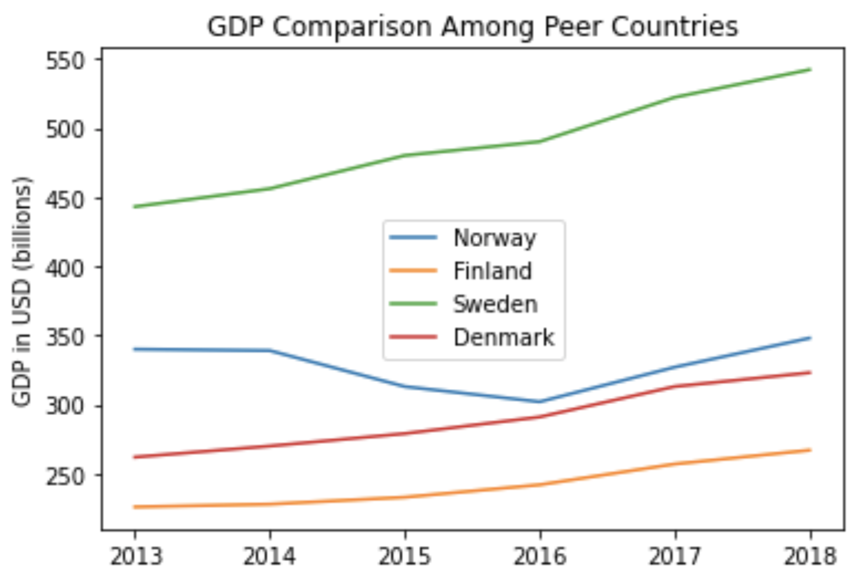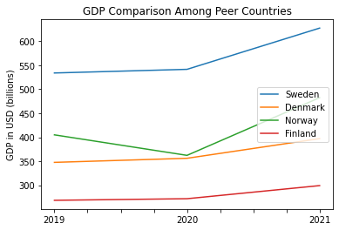

Figures 1a and 1b. GDP Comparison Among Peer Countries (left: 2013-2018; right: 2019-2021)

2.2 ECI Ranking and Changes
The Economic Complexity Index (ECI), as defined by Ricardo Hausmann and Cesar Hidalgo in 2009 to explain the knowledge accumulated in a country's population, exhibits a similar growth pattern for Norway. As illustrated in Figure 2a below, Norway (-351.33% ECI change) exhibited a decrease in terms of its production capability from 2013 to 2018, which is much more negative than Finland (-15.68%), Sweden (-33.825), and Denmark (-9.25%). Ultimately, Norway is the weakest of the peer country set, as it displays the lowest GDP growth rate and ECI change across the period.

The comparable countries maintain a small change in ECI level between 2019 and 2020, with a sharp change between 2020 and 2021. Norway exhibits a large increase in production capability in 2021 to levels not seen prior, with economic stimulus measures being one of the reasons. Norway has seen a 153.9% increase in its ECI, which is greater than Sweden's (-209.6%), Denmark's (-175.3%), and Finland's (-267.95%).
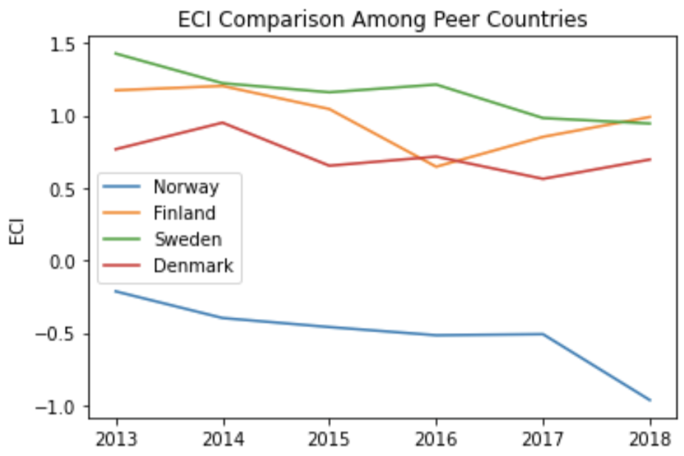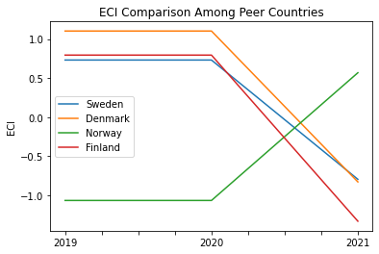
Figures 2a and 2b. ECI Comparison Among Peer Countries (left: 2013-2018; right: 2019-2021)

Figures 3a and 3b offer a further comparison of GDP Growth and ECI over the time span from 2013 to 2021 for Norway. The increase in GDP during the period from 2013 to 2018 is accompanied by a sharp decline in ECI. The results show that the economic growth experienced by Norway during the period from 2013 to 2018 is not very consistent with the predictions by ECI and Norway did not effectively make strides to develop a competitive product space that helps to accumulate complicated knowledge and technology. Unlike the volatile relationship between GDP and ECI between 2013 and 2018, GDP and ECI in 2019 to 2021 both decreased before increasing. For the period 2019 to 2021, the ECI followed GDP trends, which can be interpreted as advancements in production. In order to provide a more concrete answer to why this has happened, we will dive into an analysis of Norway’s production structure and its product space designs in the next few sections.

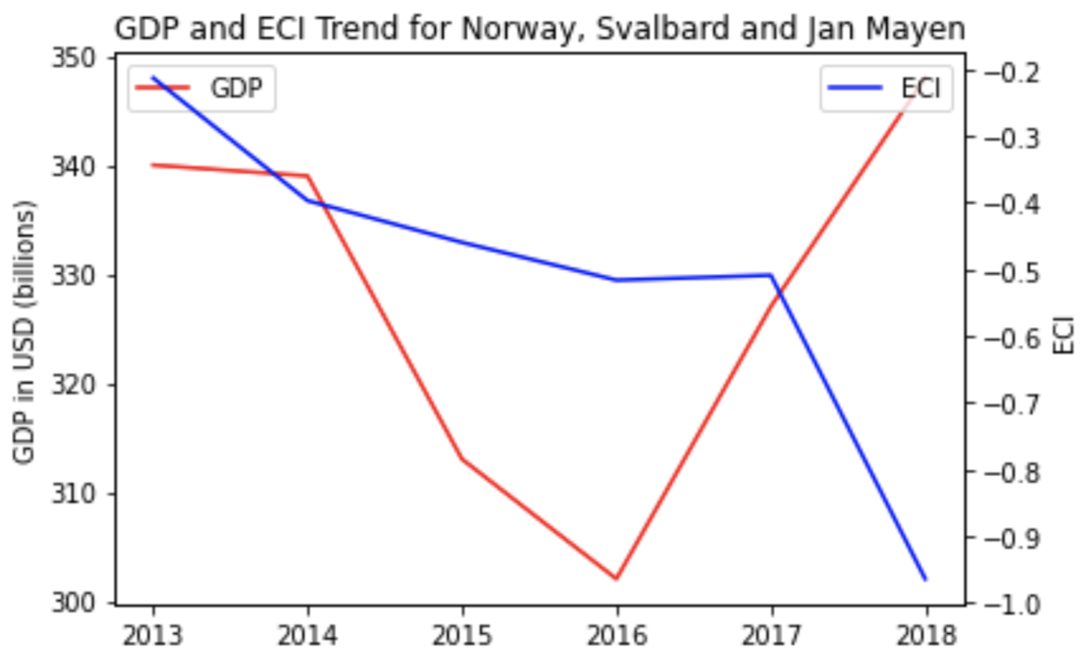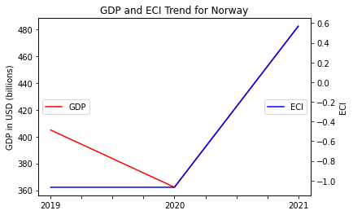

Figures 3a and 3b. GDP Growth and ECI for Norway (left: 2013-2018; right: 2019-2021)
3. Production Analysis

3.1 Product Categorization
Our main data source in this research is the UN Comtrade Website (https://comtrade.un.org), which provides us with valuable information on countries’ export values on an annual basis, including highly specific export data for more than 5000 categories of products. In order to have a holistic vision of the product space of a country, however, a level of categorization is required. Products in our data source are labelled from 010000-999999, with the first two-digits representing a general category to which the product belongs. Based on the 99 categories as extracted from the label, we further group the products into 18 most widely-accepted industries, as summarized in Table 1.

Note that the High-complexity Products industry group is not a distinct industry but rather an aggregated industry that encompasses the most complicated products from the most technologically-advanced industries (as measured by PCI). This industry serves as an indicator for us to quantitatively evaluate how well a country has performed in developing cutting-edge technologies and closing its technical gap with advanced economies, which has become a topic of wide concern today. Indeed, when we rank the 18 categories based on PfCI (an equivalent concept of PCI as calculated based on the 18 categorized product groups), the High-complexity Products industry has the highest PfCI among all industry groups.

Category | Description
Animals and By-products | All kinds of meat, livestock and related by-products
Vegetables, Fruits and Plants | All kinds of plants, edible vegetables and fruits
Food and Preparations | Edible preparations, raw cooking materials and appliances
Clothing and Accessories | All kinds of fabrics, filament, clothing and accessories
Textiles | All kinds of textile articles and related products
Wood Products | Book, paper and other elementary products related to wood
Metals | Mining of all sorts of raw Metals
Refined and Processed Stones | Refined or processed stone products such as pearl and ceramics
Energy Drilling and Mining | Mining industry for energy, minerals, stone materials, etc.
Daily Instruments | Basic daily instruments such as sport requisites, timing and measuring tools
Raw Manufacturing | Basic products made from plastic, rubber, leather, etc.
Chemical Manufacturing | Advanced chemical products and pharmaceutical products
Chemicals | Raw chemical materials and by-products
Machinery and Construction | Machinery and mechanical appliances, including electrical equipment
Transportation | Vehicles and locomotives including aircraft, ship, railway, etc.
Weapons | Explosives, arms and ammunition
Services and Utilities | Financial, business, legal, communication, travel Services and Utilities, etc.
High-complexity Products | Agglomeration of advanced products with highest PCIs

Table 1: Categorization of Products

We further observe a positive correlation between the GDP and the export of High-complexity Products. A higher adjusted R-square exists between GDP and High-complexity Products exports, indicating that more successful economics, as measured by GDP, tend to be those that are capable of producing and exporting High-complexity Products as we define them. The Figure 3 and 4 show the OLS results in a universe of 107 and 21 typical countries respectively.

 | High-complexity Products | Food and Preparations | Animals and By-products
Adj.R-squared | 0.075 | 0.006 | 0.002
F-statistic | 9.556 | 1.638 | 1.175
No. Observations | 107 | 107 | 107

Figure 3: OLS Regression Results of GDP against Percentage Volume of Exports

 | High-complexity Products | Food and Preparations | Animals and By-products
Adj.R-squared | 0.149 | 0.003 | -0.012
F-statistic | 4.510 | 1.059 | 0.7542
No. Observations | 21 | 21 | 21

Figure 4: OLS Regression Results of GDP against Volume of Percentage Exports

3.2 Realized Industry Development
Based on the product categorization aforementioned, we aim to capture Norway’s realized industry production strategy between 2013 and 2021 on a complexity level. In Hausmann and Hidalgo (2009), distance is defined to be a measure of how far a country is from a certain product not in its product space. We extend this concept to all product groups and quantify how technically equipped a country is to develop the corresponding product groups. In other words, the shorter the distance between a country and a product group, the more capable a country is in developing products within that group. Defining this net distance change as the Realized Industry Development (RID), our export data allow us to calculate and compare RID of US and the 18 product groups in 2013 and 2018 through subtraction, where a positive RID indicates a shortening of the distance (i.e., advancement of the industry), and a negative RID indicates the reverse. It is notable that the number of industries with positive RID has decreased from 16 to 14 from 2018 to 2021.

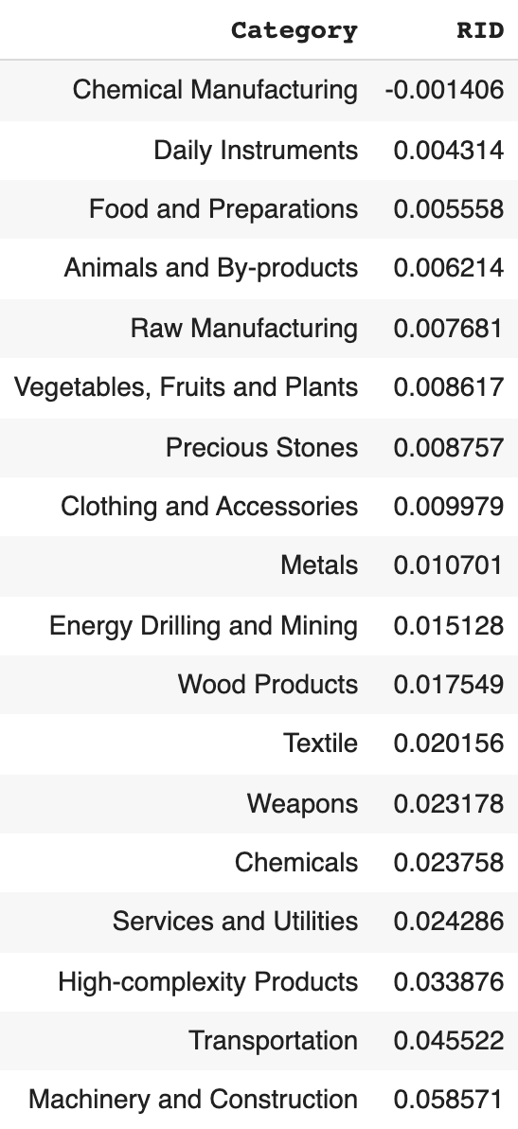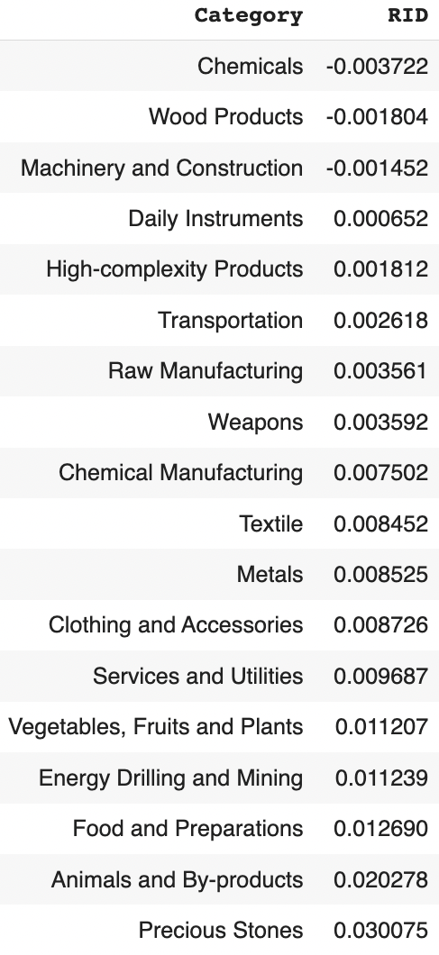
Table 3: Realized Industry Development (RID) of Norway

3.3 Regional and Global Comparison
Tables 4a-4b below summarize how the production strategy adopted by Norway compares with selected leading economies in the world across different years, as measured in RID. Leading economies such as France, the United States and Germany gave a considerable level of attention to more advanced product groups such as Weapons and High-Complexity Products in 2018 and Services and Utilities, Precious Stones, and High-Complexity Products in 2021.

Ranking | France | the UK | Germany
1 | High-complexity Products | Services and Utilities | High-complexity Products
2 | Chemical Manufacturing | Weapons | Transportation
3 | Daily Instruments | Raw Manufacturing | Wood Products
4 | Animals and By-products | Precious Stones | Metals
5 | Food and Preparations | Animals and By-products | Food and Preparations
Table 4a. RID Comparison across Leading Economies (2018)

Ranking | France | the UK | Germany
1 | Services and Utilities | Precious Stones | Daily Instruments
2 | Precious Stones | High-complexity Products | Transportation
3 | High-complexity Products | Services and Utilities | Chemicals
4 | Energy Drilling and Mining | Energy Drilling and Mining | Chemical Manufacturing
5 | Machinery and Construction | Wood Products | Clothing and Accessories
Table 4b. RID Comparison across Leading Economies (2021)

Tables 4c-4d further examine Norway’s development strategy against those of emerging economies on a global scale. Reasonably, emerging economies such as China, South Korea, and Singapore, have devoted the majority of their efforts to intermediate industry groups, showing drastic shifts in strategies over the course of three years.

Ranking | China | South Korea | Singapore
1 | High-complexity Products | Transportation | Transportation
2 | Transportation | Textile | High-complexity Products
3 | Machinery and Construction | High-complexity Products | Precious Stones
4 | Energy Drilling and Mining | Chemical Manufacturing | Daily Instruments
5 | Daily Instruments | Machinery and Construction | Services and Utilities
Table 4c. RID Comparison across Emerging Economies (2018)

Ranking | China | South Korea | Singapore
1 | Chemicals | Chemicals | Weapons
2 | Daily Instruments | Daily Instruments | Energy Drilling and Mining
3 | Transportation | Transportation | Transportation
4 | Raw Manufacturing | Textile | Machinery and Construction
5 | Weapons | Raw Manufacturing | High-complexity Products
Table 4d. RID Comparison across Emerging Economies (2021)

4. Product Space Design

4.1 Suggested Development Vector
As aforementioned, distance gives us an idea of how far each new product is from a country’s current mix of exports. As defined in Hausmann and Hidalgo (2009), distance is “the weighted proportion of products connected to goods p that country c is not exporting, i.e., MCP=0.” Based on this definition, the distance between a country and any product that the country is currently exporting (i.e., the country is a significant exporter in the product as compared to global average) is zero. Similarly, opportunity gain quantifies the contribution of a new product in terms of opening up the doors to more and more complex products. Intuitively, a product that a country is currently exporting (i.e., MCP=1) has an opportunity gain of zero. And unreasonable investment on certain product p would lead to a relative decrement in export of more profitable products, and therefore lead to a negative opportunity gain of product p. The opportunity gain is not the only estimator of a country’s level of economic development. However, among countries with comparable economics strength, those having higher ECI, or in other words, more reasonable economics structures are often in better shape.
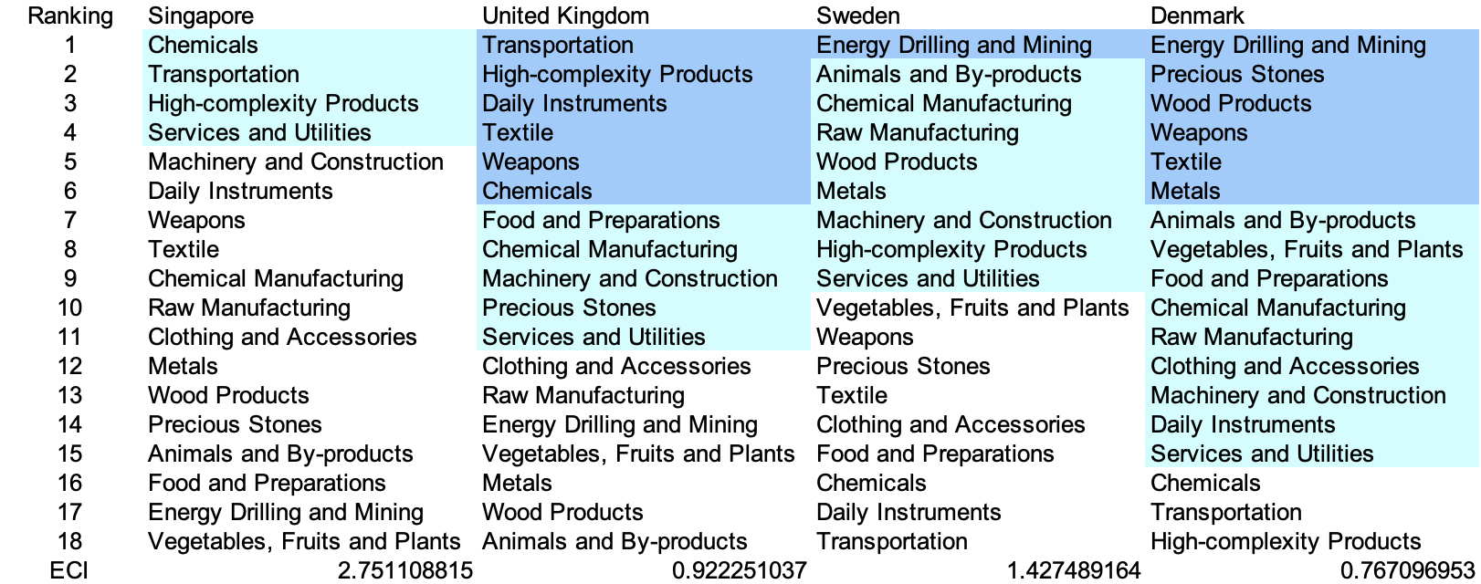
Table 5a. Opportunity Gain Ranking on a Comparable Scale (2013)

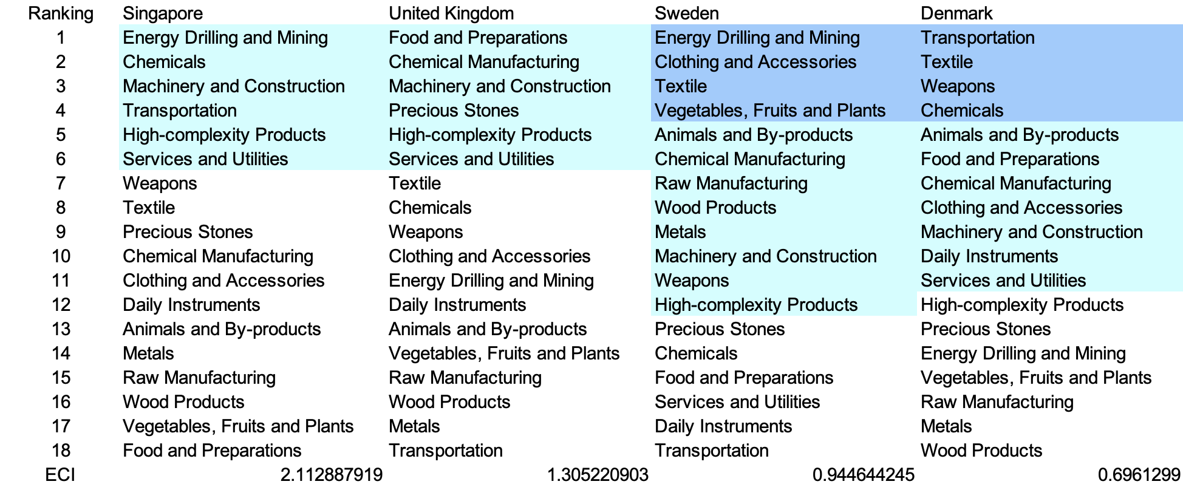
Table 5b. Opportunity Gain Ranking on a Comparable Scale (2018)

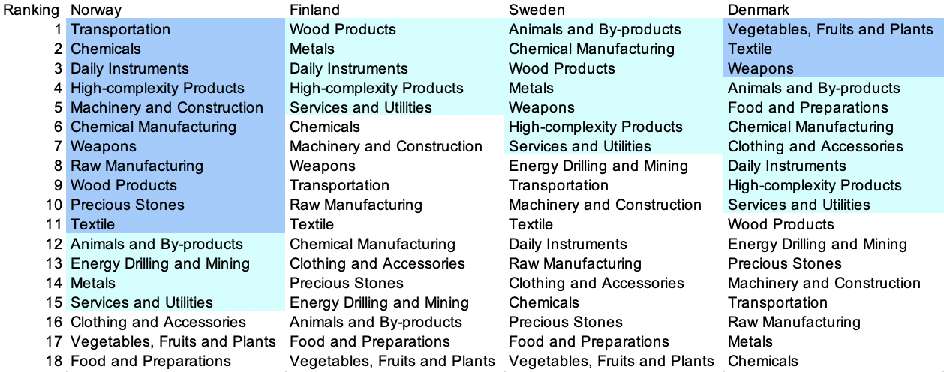
Table 5c. Opportunity Gain Ranking on a Comparable Scale (2021)

We define the ranking of opportunity gain for a country c, as the Suggested Development Vector (SDV) of c. Tables 5a-5c summarize how the SDV of Norway compares with a selected group of regional and leading economies in the world, with the industry groups ranked in decreasing order of significance. We focus on SDV results for 2018 because they give the most accurate snapshot of complexity for global comparison in the absence of the irregular effects of the COVID-19 pandemic observed in 2021.

Dark blue indicates positive opportunity gain, light blue indicates zero opportunity gains, and white indicates negative opportunity gains. The result shows that leading countries barely have any industries with positive opportunity gain. In other words, those countries are already in the most stable and efficient economic structure. Without the necessity of economic transition, those countries merely need to maintain a steady and balanced economic development. In contrast, developing countries have nearly half of industries with positive opportunity gain, and share common interests in industrial manufacturing and High-complexity Products industries. It can be concluded that Norway shares the characters of developing countries, with a balanced economics structure that leans towards intermediate-level industries.


Table 6: SDV of Other Typical Countries 2013

4.2 Budgeted Industry Development Strategy and Interpretation

The optimal budgeted industry development strategy aims to solve the most efficient allocations under the budgeted constraint of different situations of heuristic total export growth. In order to obtain such an allocation portfolio, we formulate an optimization problem as the following:



where k(x) is the second largest eigenvector of $M_{CC'}$ after adding $x$ to the original export vector, C is the country that we are interested in, P is the product space, B is the heuristic budget.

If we can solve this problem, then we can know what the largest ECI that a country can improve to. Accordingly, the optimal solution $x*$ that we obtain here is exactly our optimal allocation. However, the biggest problem is that the objective function is not convex. Therefore, we cannot apply the classical tools for convex optimization on this problem. In order to solve this problem, our idea is to use greedy algorithm. The way that we apply greedy algorithm is that firstly we separate the total budget into k equal parts, and then for the first equal part we try to search for the product that can optimize our objective function by iterating through each $p∈P$. After we find the optimal product p for this equal part, we add the amount back to the export value of this product p and update the ECI for this country. If we observe that ECI does not change after iterating all the products, then we can add up one more equal part to invest. Until we find there is an ECI increment, we add the amount now to that product. The rest equal parts can be done in the same way.

However, as is known to all, greedy algorithm is a kind of local search algorithm, which is pretty possible to run into a local minimum. Therefore, for local search algorithms, one typical way is to keep it away from the local minimum is to enhance the vision of the algorithm by looking more steps forward. In our setting, whenever we obtain an increment of ECI, we mark down the required amount of export growth. Simultaneously, we continue searching for the next ECI increment point, compare the ratios of these two possibilities and pick the largest one. The ratio is defined as the following:


where ${ECI}_{p}$ is just the ECI of the country after adding some amount of export increment to product $p$, which is exactly the amount that is able to make ECI change. Also, we can express it in the way of $||$$x_{p}-x_{0}$${||}_{1}$.

In this way, we can obtain a further sighted greedy algorithm. Also, the number of parts that we would like to separate the budget into also matters. In order to solve this problem, we added a stabilizer on top of the enhanced greedy algorithm, by running the algorithm for different numbers of parts and selecting the portfolio with the largest ECI increment and most complex economic structure.

Besides, it is quite common that there is a surplus for the budget. To deal with the surplus, we just add it to the product which needs the least amount of dollar to make $M_{cp}$ = 1, (i.e., the smallest amount of required export increase).

Interpretation:

For the purpose of a clear explanation of the line charts, we try to label all the products in Table 7. Please refer to this table when trying to understand the investment trajectories in the line charts.

Label | Product Names
1 | Animal and By-products
2 | Vegetables, Fruits and Plants
3 | Food and Preparations
4 | Energy Drilling and Mining
5 | Chemicals
6 | Chemical Manufacturing
7 | Raw Manufacturing
8 | Wood Products
9 | Clothing and Accessories
10 | Textile
11 | Metals
12 | Machinery and Construction
13 | Transportation
14 | Weapons
15 | Daily Instruments
16 | Precious Stones
17 | High-complexity Products
18 | Services and Utilities
Table 7. Products Labeling

Below is the economic panel for Norway in 2013. We can see that for different percentages of heuristic total export growth, the ECIs of Norway have different amounts of increments. Overall, 5 and 10 percent export growth result in a high ECI improvement pattern, which starts from around -0.21 and ends at around 0.44. However, 15 and 20 percent export growth are able to result in obvious ECI improvement trajectories. For a 15 percent growth budget, ECI of Norway is able to end at around 0.71 while for a 20 percent budget, the increment is even more obvious, eventually achieving around 1.08.

For the case of 5 percent export Daily Instruments, Chemicals and Textiles account for most of the portfolio. For 10 percent export growth, in addition to the industries that we mentioned before, more weights are put on other industries, such as Wood Products, and Vegetables, Fruits and Plants. In these two ECI improvement trajectories, we also notice that the largest improvement comes from Wood Products, suggesting that with a low economic improvement anticipation, Norway should focus more on developing the industry of Wood Products. For the case of 15 and 20 percent increment budgets, we realize that the development trajectories are in a similar pattern except that there are a few additional steps when there are more budgets. Different from the previous two cases, the solutions suggest that Norway should invest more on machinery and construction and weapons. This makes sense because with more budgets, a country should definitely focus more on the development of high-end product spaces. A more detailed numerical representation of the portfolio is shown in Table 8.

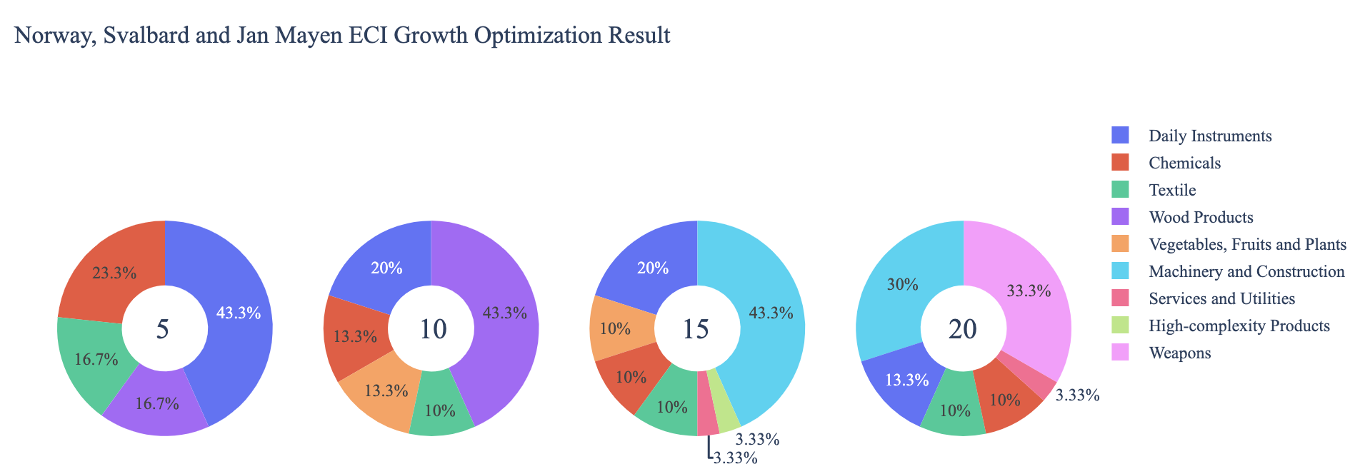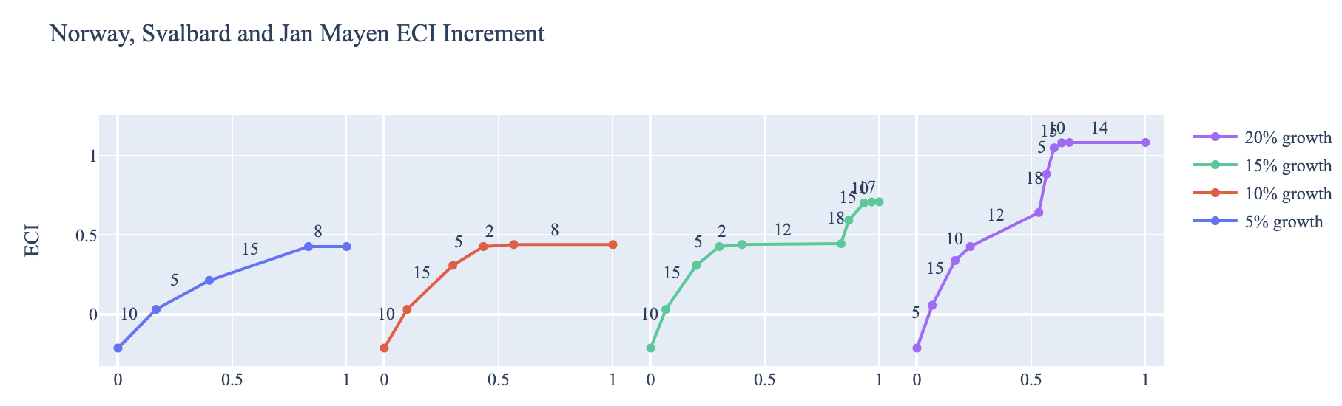

Figure 8a. Greedy-Based ECI Improvement Results of Norway with Different Budgets (2013)

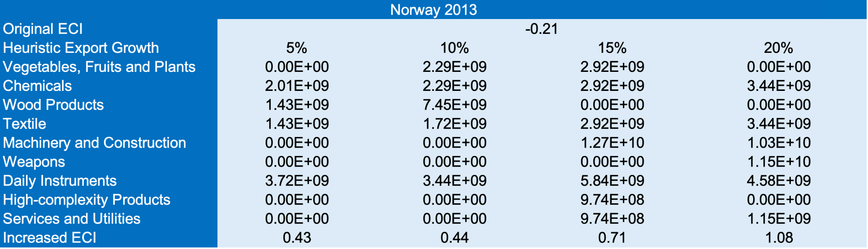

Table 8a: Portfolio of Norway in 2013
For further suggestions on Norway’s development in the future. We also offer the optimization result of Norway based on export data in 2018. Below is the economic panel for Norway in 2018. We can see that there is a similar pattern for the ECI improvement trajectories, which is that the improvements in 5 and 10 percent export growth are similar, and the ones in 15 and 20 are lower. The main components of the ECI Optimization Results are also very similar to the 2013 case for the 5 percent case. For a 10 percent growth, the main components also consist of chemical manufacturing and Daily Instruments. For situations with higher budgets of investment, like 15 or 20 percent of growth, the portfolios are much more diverse than the previous two cases. In addition to the previously mentioned industries, industries like chemical manufacturing and daily instruments, Machinery & Construction are the ones that contribute a lot in ECI increments. A more detailed numerical representation of the portfolio is shown in Table 9.

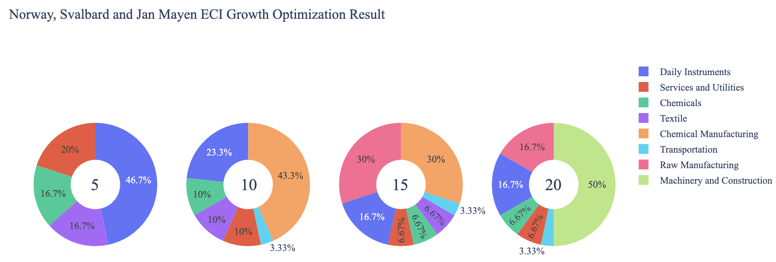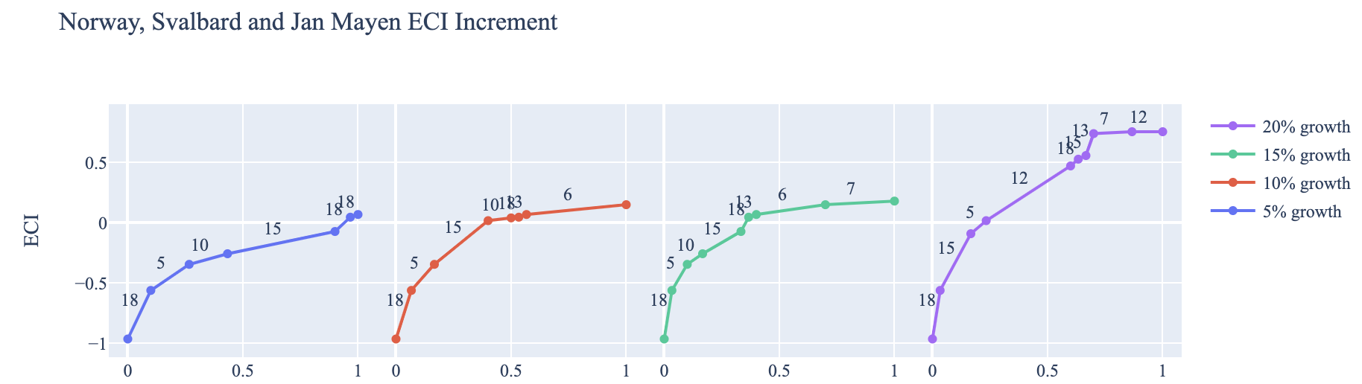

Figure 8b: Greedy Based ECI Improvement Results of Norway in 2018 with Different Budgets

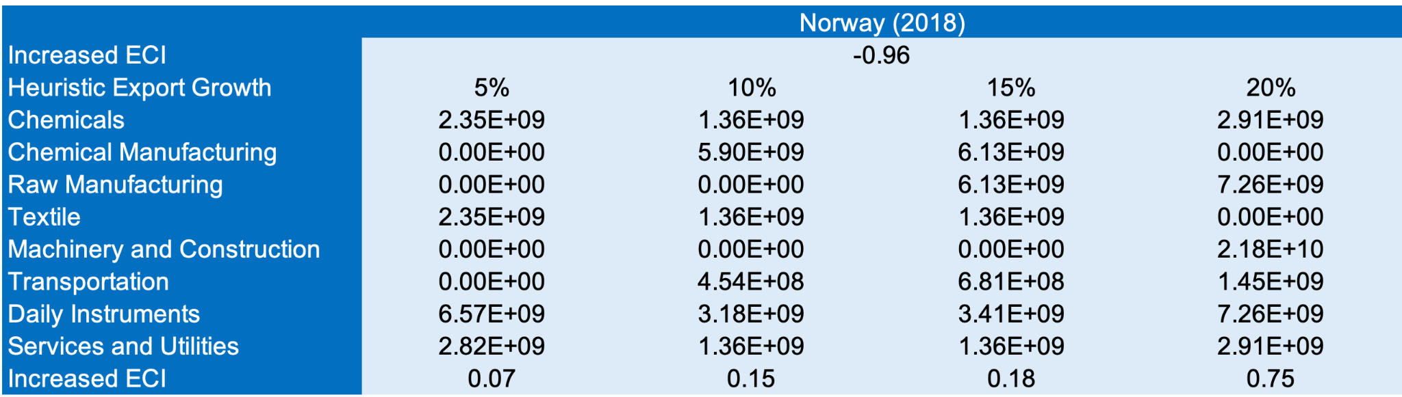
Table 8b: Portfolio of Norway in 2018
To compare with the performance in 2013 and 2018, we also re-examine suggested strategies for 2021. For 2021, a 5% increase in export would emphasize Vegetables, Fruits, and Plants and Food and Preparation. At 10% and 15%, Precious Stones also becomes a major industry, while at 20%, Transportation becomes the key to growth. These strategies go in line with the suggested trajectories based on ECI. Norway’s GDP and ECI have experienced consistent growth over the years, and its focus on Precious Stones can be attributed to this growth. A more detailed numerical representation of the portfolio for Norway is shown in Table 8c.

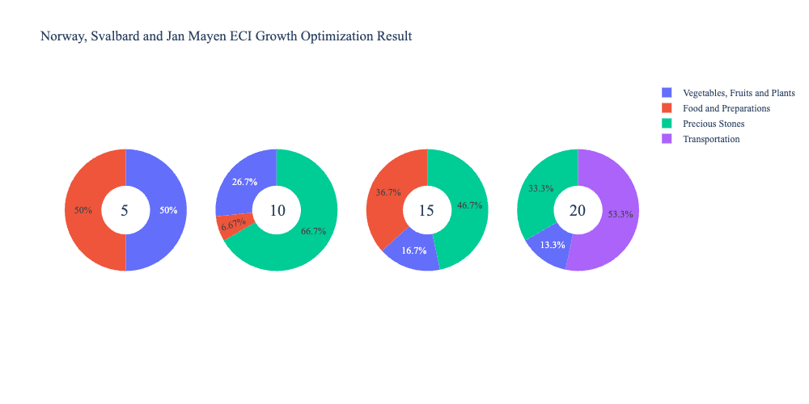
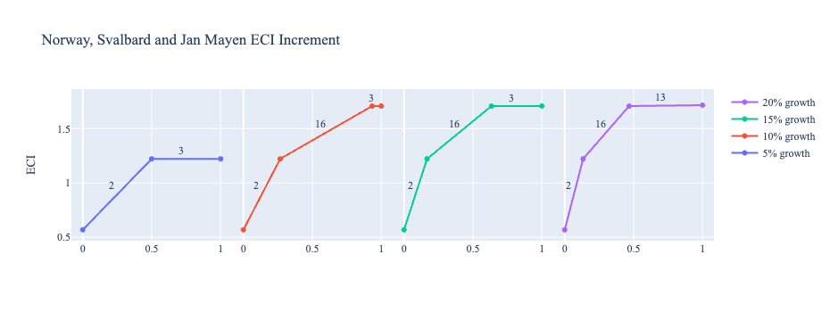
Figure 4c. Greedy-Based ECI Improvement Results of Norway with Different Budgets (2021)
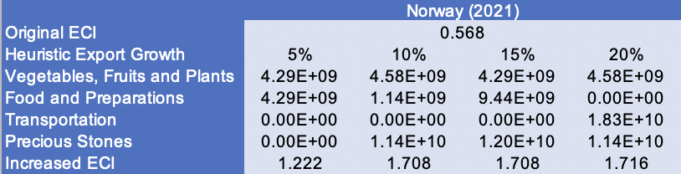
Table 8c. Portfolio of Norway (2021)
4.3 Sensitivity Analysis and Contingency Strategy
In the following section our broad aim is to understand how sensitive Norway is to changes in export in various industries. While the Economic Complexity Index has been shown to contain valuable information about the economic strength/capacity of a country, little has been said as to the stability of the measure itself. We seek to uncover the main drivers of stability under a country's ECI score and better understand longer-term projections for ECI growth. Additionally, gaining an intuition on the industries that are bolstering an economy and the industries that offer the greatest return per unit of investment is best done through visualization of industry specific sensitivity. To this end, we have developed two categories of sensitivity analysis.
ECI Sensitivity Graph
Firstly, in order to assess the effect particular industries have on each respective country, we developed ECI Sensitivity graphs. We use shocking methodology to increment or decrement an industry’s export level by a certain percentage and recalculate the ECI all else being equal. While freezing the export dynamics of the rest of the world and enacting an instantaneous shock in export for a particular industry and country may not reflect real-life dynamics, what it does offer us is an understanding of a country’s level of dependency on an industry in the context of ECI. The shocking is done in small percentage increments in order to smooth out the resulting curve. Additionally, a recurring theme one will see is that for most industries, a breaking point occurs where the ECI either jumps upwards or downwards, creating a hockey stick shape rather than a linear trend. While the inflection point may not be accurate in the context of real life, comparing the various inflection points across industries can give us valuable insight.
The graphs are formulated as follows: There are four ECI Sensitivity graphs. The first two represent data from 2018. The first chart shows positive shocks in which export numbers are shocked upwards per industry. The X-axis is in terms of percentage shock per current dollar value of export. The Y-axis is the recalculated ECI level post-shocking. The second chart follows the same format except the X-axis represents negative shocking. In other words, exports for each industry are decremented and the ECI is accordingly recomputed. The final two sensitivity graphs show the same results using 2013 data. Below is an example of an ECI sensitivity graph.

Example 2018 (Incremental ECI Sensitivity)
SDV sensitivity
Secondly, we analyze the sensitivity of the SDV to changes in export levels. The goal is to understand how export level changes for a particular industry can affect the marginal opportunity gain for other industries. We will be using specifically High Complexity Products and Food and Preparations as our base industries. We will be increasing or decreasing the absolute export level in both of these industries and observing the effects on the SDV.
When the opportunity gain of an industry is negative, the SDV sensitivity approximates how an over-development of the industry jeopardizes the economic structure of a country. When the opportunity gain of the industry is zero, the SDV sensitivity determines whether the further development of the industry shapes the country with a better economic structure and predicts how the SDV would change accordingly. Specifically, as we reduce the export of such an industry to 25%-50% of its original value, a few other industries originally with negative opportunity gain could likely become profitable.
Similar to the ECI sensitivity graphs above, we will be shocking the export of High Complexity Products and Food and Preparations in small percentage increments. A new SDV, represented by a new column in the charts, is recorded only when a certain level of shock changes the structure of the SDV. In effect we are incrementing or decrementing export levels of two industries until the marginal opportunity gain of any industry changes in category (positive, negative, or neutral). Below is an example of a SDV Sensitivity chart with Positive Shocking. Industries with positive marginal opportunity gain are colored blue, neutral is colored white and negative is colored red.


Example High-complexity Products 2018 (Incremental SDV Sensitivity)


Example Contingency Strategy 2018

4.3 Sensitivity Analysis Results and Interpretation
We examine Norway’s ECI Decremental and Incremental Sensitivity Charts for 2021. An increase in Chemicals will lead to the highest change in ECI, followed by Daily Instruments. The strong sensitivity effect of manipulating the Daily Instruments category remains consistent with previous years. For the negative shock cases, Energy, Drilling, and Mining becomes most impactful, with large decreases leading to an increased ECI. This trend remains consistent across years. The rest of the industries do not appear to have the same level of sensitivity.

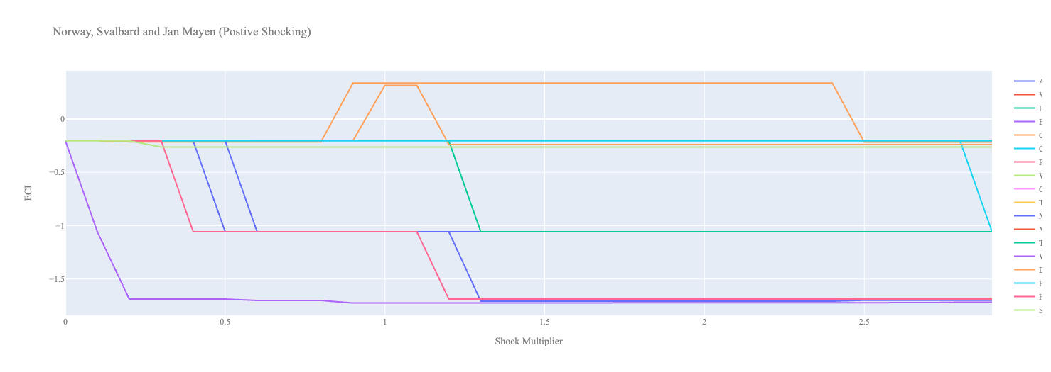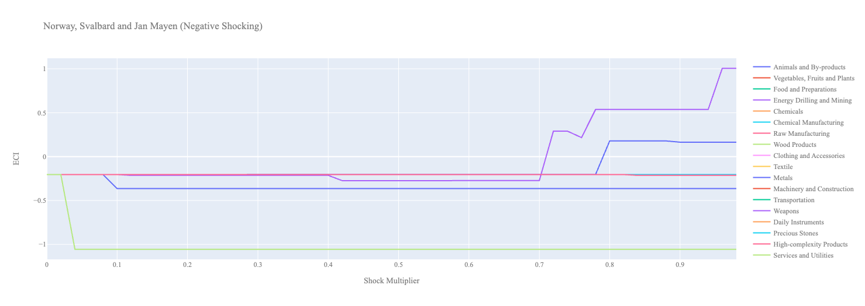
Figure 6a. Incremental ECI Sensitivity for Norway (2021)
Figure 6b. Decremental ECI Sensitivity for Norway (2021)

Below is Norway’s 2018 ECI Sensitivity Charts. Firstly in the positive chart, we notice immediately that increases in Daily Instruments and Machinery & Construction lead to an uptrend in ECI. Machinery & Construction offer the best ECI growth per unit of export increase. All other industries tend to not greatly affect the ECI level making it fairly clear which industries to pursue.

Next we consider Norway’s 2018 Negative Shock chart. We see that Norway’s ECI is slightly sensitive to drawdowns in Metals and Services and Utilities. More interestingly we see that large decreases in Energy, Drilling, and Mining seem to greatly increase the ECI score. These industries are very important for Norway’s economy and thus the results that are reflected in the chart may be suggesting that there is another industry that could be very beneficial for Norway that is far in proximity from Machinery & Construction and Daily Instruments.
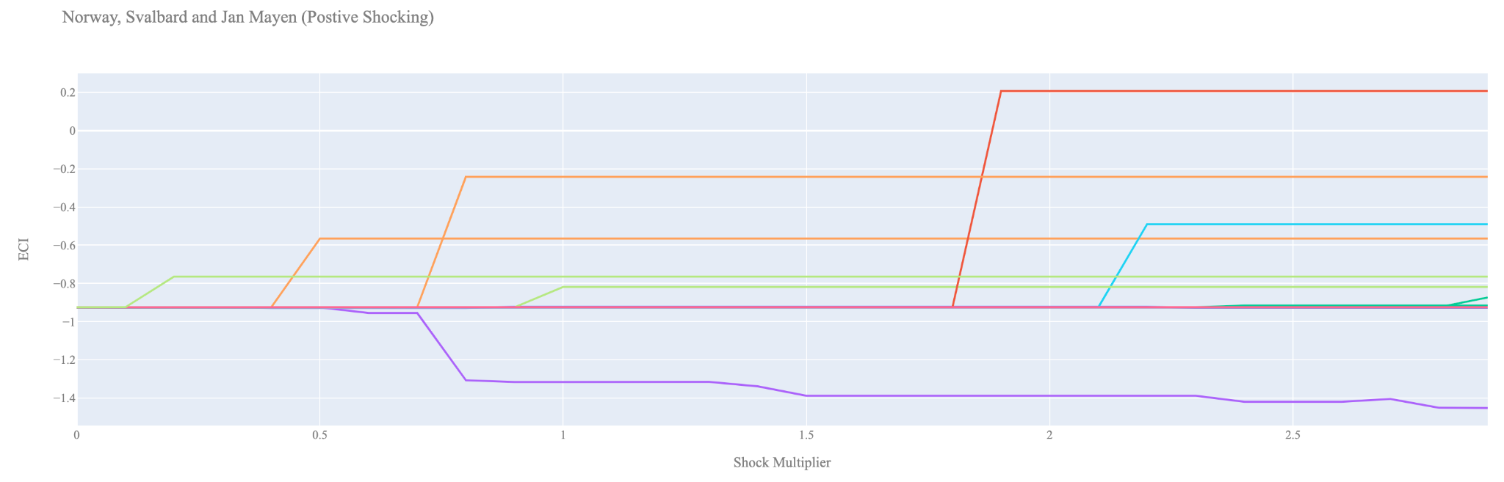
Figure 7a. Incremental ECI Sensitivity for Norway (2018)
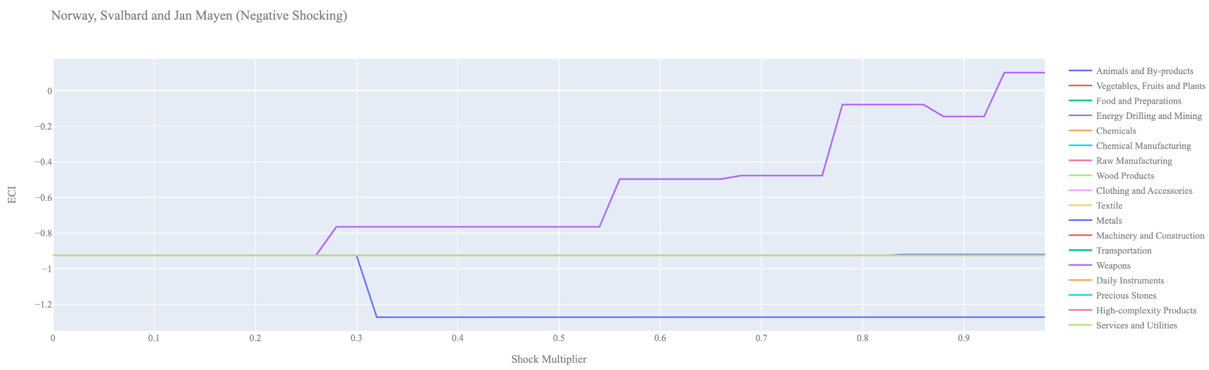

Figure 7b. Decremental ECI Sensitivity for Norway (2018)
Next we consider the 2013 ECI Sensitivity graphs. We see that in the positive shocking case, the landscape of ECI sensitivity has not altered significantly over the five year period. Machinery and construction and Daily Instruments seem to offer the best ECI growth prospects.

In the 2013 negative shocking case, we see that again Norway is very sensitive to drawdowns in Machinery & Construction and Daily Instruments.

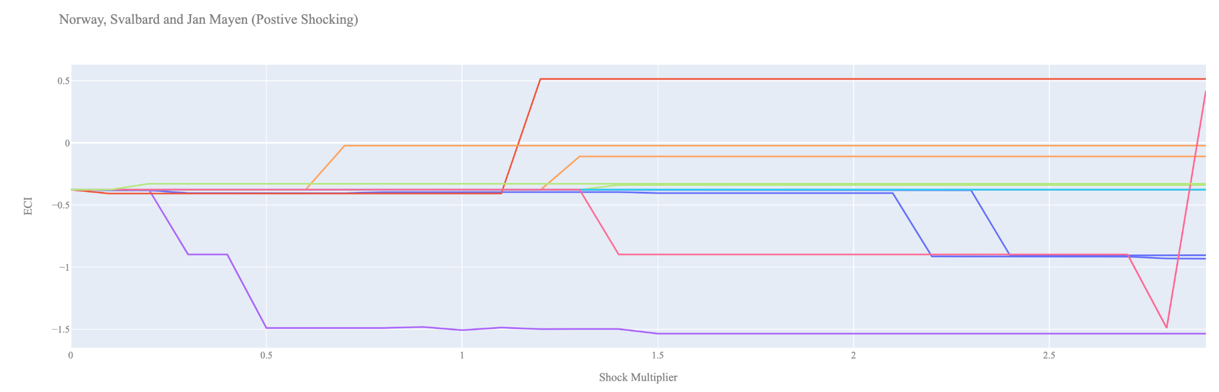

Figure 8a. Incremental ECI Sensitivity for Norway (2013)

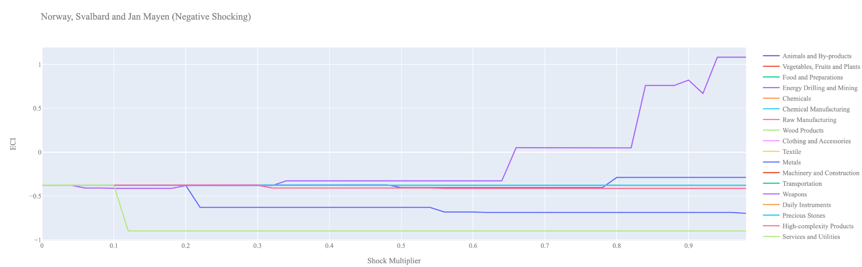
Figure 8b. Decremental ECI Sensitivity for Norway (2013)

Below we see the SDV sensitivity charts for Machinery & Construction. We see that increasing the export of Machinery & Construction does not open up any new positive opportunity gain industries for Norway to move into, instead it decreases an industry which can yield positive gains in ECI, namely Machinery & Construction. In fact after about a 190% increase it is no longer for Norway to continue exporting Machinery & Construction.

As expected in the negative Machinery & Construction DSV chart we see that there is no way to gain additional ECI by decreasing the export of Machinery and Construction. Hence the ECI stays at its original level.

Concerning Weapons, Norway seems to be mostly insensitive to this industry suggesting that this is not an important industry in terms of the stability of its SDV.

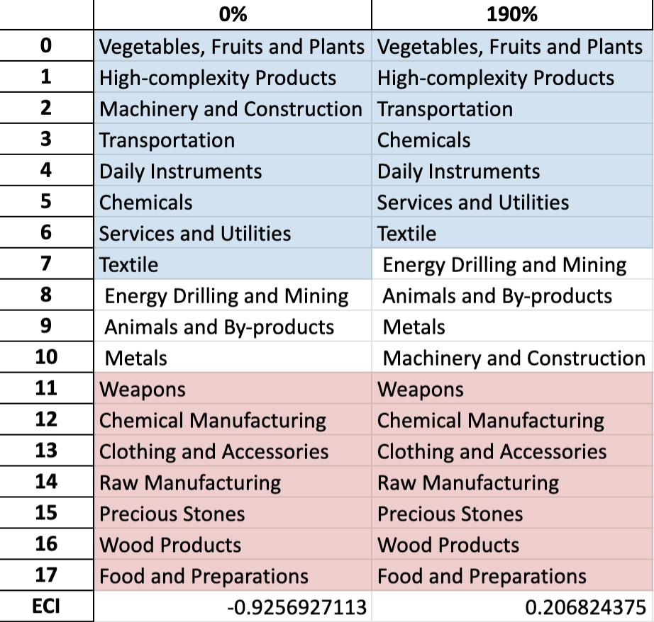

Norway Machinery & Construction 2018 (Incremental SDV Sensitivity)
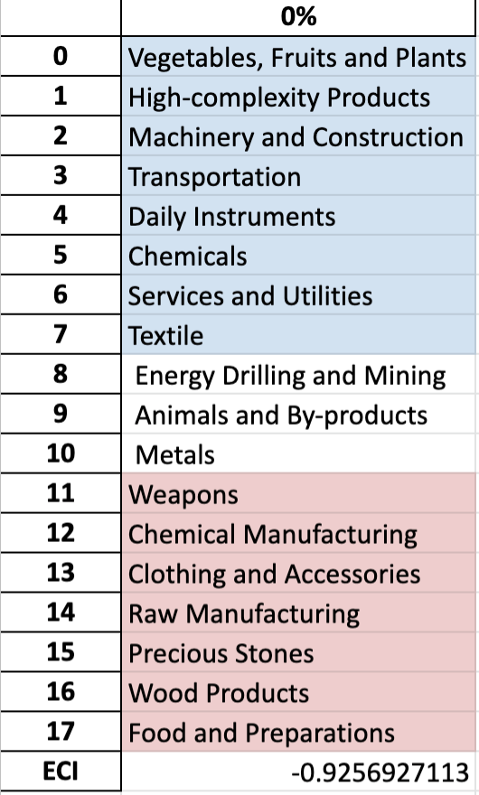
Norway Machinery & Construction 2018 (Decremental SDV Sensitivity)

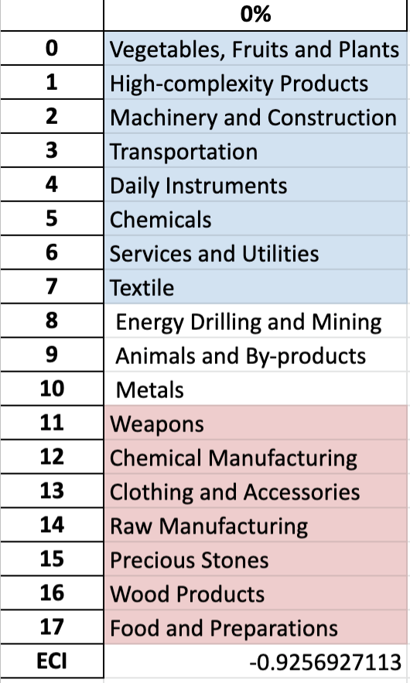
Norway Weapons 2018 (Incremental SDV Sensitivity)
Norway Weapons 2018 (Decremental SDV Sensitivity)

4.4 Contingency Strategy

Decreasing export of each industry in Norway current production space by 60% respectively, we derive the contingency strategy shown below.

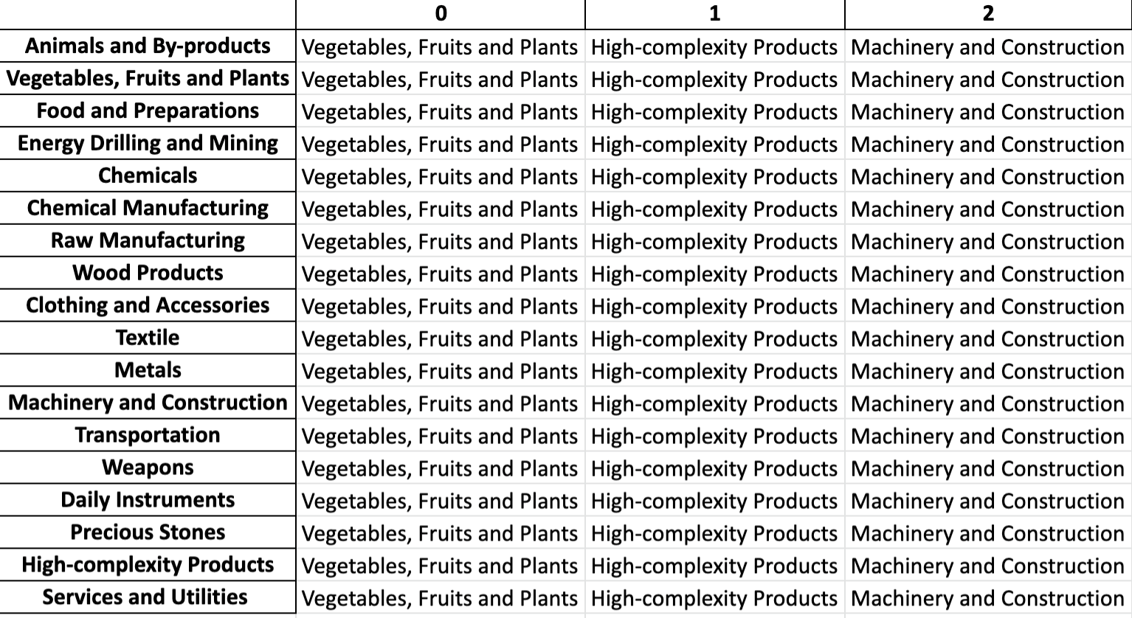
Norway Contingency Strategy 2018

5. Macro-level Predictions

5.1 Structural Optimality Index
Indeed, such choice of prioritization has proven to be a significant factor in deciding the economic outcomes of countries. In order to quantitatively evaluate how effective our development strategies are and how deviations from the suggested developmental path will lead to suboptimal growth results, we define the measure – Structural Optimality Index (SOI) – on a country level as the Adjusted R-Square obtained from regressing the country’s realized industry development over the suggested development strategy. Both strategies are quantified in nature, with the realized development represented by export increase in every major industry group and the suggested development strategy represented by the opportunity gains of developing the corresponding industry groups as calculated in previous sections. The adjusted R-square from the regression thus provides us with a quantified measure of how the development path adopted by the country has fitted with/differed from calculations on a complexity level.

After obtaining this measure for all countries in our database, we further regress countries’ five-year economic growth, which is defined as the percent increase in GDP (USD), over their SOI. Figure 6 illustrates the regression output, which shows a strong positive correlation between countries’ SOI and their five-year GDP growth, significant at the 1% level and achieving an adjusted R² of 4.5%. In other words, the more a country develops as suggested by calculations on a complexity level, the better economic outcomes it achieves.

Table 18: OLS Regression Results
Dep. Variable: GDP | F-Statistic: 5.963
R²: 0.054 | Prob (F-Stat): 0.0163
Adj R²: 0.045 | No. Observations: 106

Figure 9. Regression of Five-Year GDP Growth over SOI (2013-2018)

5.2 SOI of Norway and Its Implications
Norway for instance, has a high level of structural optimality as compared with its developed peers. As the regression in Figure 7 suggests (the orange curve represents export increase and the blue curve stands for opportunity gain of the corresponding industry), Norway demonstrates an average level of correlation with the suggested developmental path, having an adjusted R-square of around 19.5%. Norway ranks in bottom quartile among all countries in terms of SOI and has made a low rate of economic progress below its developed peers from 2013 to 2018 with a 5-year GDP growth rate of 0.54%, which is consistent with the regression result in Figure 6. This is in contrast to other developed economies such as Japan, where there is low SOI of around -5.7% and a corresponding GDP growth of 9.05% from 2013 to 2018, making it a much slower developing economy during the period. In sum, Norway’s mixed economic progress from 2013 to 2018 can be at least partially explained by a development strategy that demonstrates a decent, but not perfect, level of matches with our suggested developmental path. In specific,Norway invested heavily in the Machinery and Construction industry, while it should have focused more on more complex industry groups such as Energy Drilling and Mining and Raw Manufacturing. That being said, it stayed fairly in line with our expectations in the wood products industry.

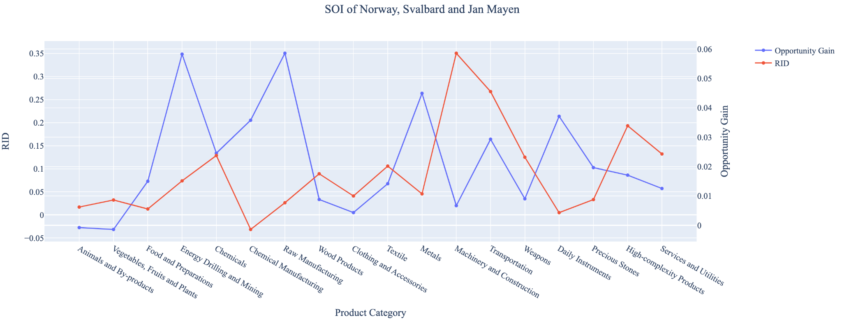
Figure 10a. SOI of Norway (2013-2018)

For the 2019-2021 years, Norway has a strong presence in the Precious Stones and Animals and By-product industries, which both seem to be overdeveloped when considering their lower opportunity gain relative to RID. It also could consider Machinery and Construction, and Weapons to improve its growth. Norway has seen a growth in GDP over those three years with an average growth of 7.55%, compared to 0.54% for the average yearly growth for the five years prior.

Lower than before, its adjusted R-squared value of 4.38% now indicates a low correlation between the GDP growth and the implemented development path. Progress is slow on a global scale during this period, but Norway demonstrates a greater ability to adjust to negative economic shocks by increasing GDP growth than it did between 2013 and 2018.
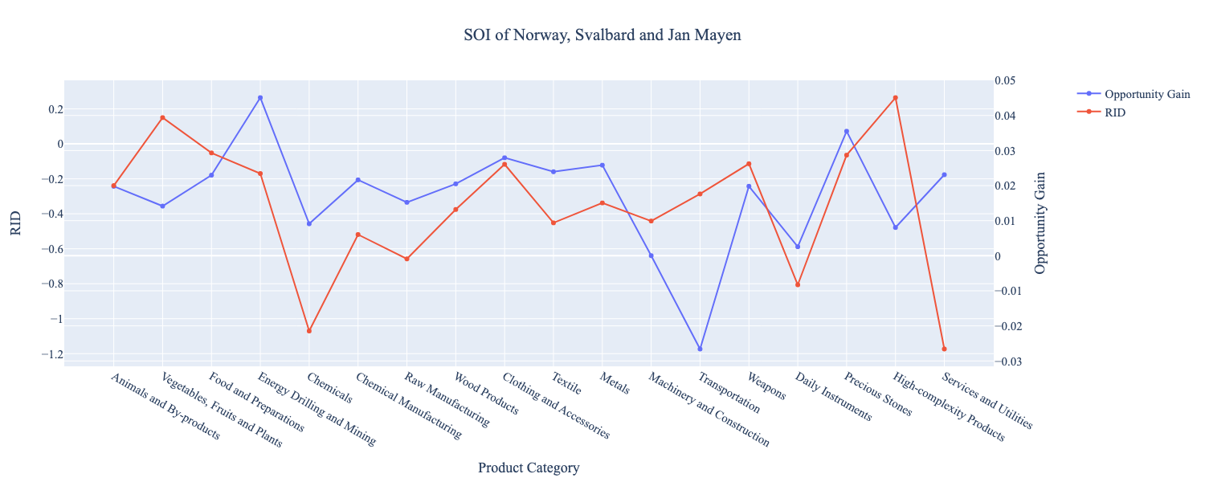
Figure 10b. SOI of Norway (2019-2021)

6. Concluding Remarks

In conclusion, Norway has demonstrated a moderate level of economic growth in terms of annual GDP increase during the period from 2013 to 2018, concurrent with a decrease in economic complexity as compared with other major developed economies. For 2019-2021, the growth in GDP has increased alongside a large boost in ECI, in line with its comparable countries and higher than some of the leading economies in the world.

We believe the lack of progress during the period can be partially explained through analysis of the economic and product complexity structure of Norway on the industry group level. The product classification system we adopt allows us to measure the realized industry development for various industry groups and to observe that Norway consistently relied on developing the Transportation from 2013-2018, while its developed counterparts and emerging economies around the globe have adopted much more complex and progressive paths.

Based on our analysis of the opportunity gain and a sensitivity analysis of major industry groups in 2013-2018, Norway can further its gains by prioritizing Machinery and Construction. We further note that Norway has a slightly mismatched development strategy that indicates a moderately high (compared to other developed countries) level of structural optimality on the complexity level, having an adjusted R-square of around 19.5%. Since a significant positive correlation exists between five-year GDP growth and the structural optimality index of an economy as we define and calculate, Norway, however, still has a suboptimal growth experience as compared with fast-growing economies both on a regional scale and on a global scale, and has the potential to further its economic gains through industrial structure optimization as suggested in the paper.

During the second examined period from 2019 to 2021, Norway performed much stronger in terms of ECI than before and compared to other countries, particularly Finland. We infer that during the COVID-19 period, Norway focused on developing Precious Stones and Energy, Drilling, and Mining which contributed to its growth in ECI. We also note that Norway has not increased its investment in the sectors identified earlier, such as Machinery and Construction, which can be attributed to the disruptions due to the pandemic. The ECI suggests that greater growth could have been achieved through Vegetables, Fruits, and Plants and that Norway is susceptible to changes in Chemicals and Daily Instruments. Despite growth in GDP and ECI, the adjusted R-squared value dropped to 4.38% in 2021 from 19.5% in 2018. We infer that Norway continued investing in current key sectors but can benefit from diversifying its allocation to other sensitive sectors mentioned above. With the revised focus, Norway has further potential to advance its economic growth to maintain its position among other countries to continue its ongoing economic expansion.

References

Hausmann, R., Hidalgo, C., Bustos, S., Coscia, M., Chung, S., Jimenez, J., Simoes, A. and Yıldırım, M. (2007). The Atlas of Economic Complexity. [online] Atlas.cid.harvard.edu. Available at: http://atlas.cid.harvard.edu/.

Balassa, B., “The Purchasing Power Parity Doctrine - A Reapprais- al,” Journal of Political Economy 72, 584-596 (1964).

Feenstra, R.; Lipsey, R.; Deng, H.; Ma, A. & Mo, H. “World Trade Flows: 1962-2000” NBER working paper 11040. National Bureau of Economic Research, Cambridge MA (2005).

United Nations Commodity Trade Statistics Database (http://comtrade.un.org/db/), accessed in August 2019.

The World Economic Forum, “The global competitiveness report,” (various years).

Barro, R. & Lee, J-W. “A New Data Set of Educational Attainment in the World, 1950-2010,” NBER Working Paper No. 1590 (2010).

Kaufmann, D. & Kraay, A. “Governance Indicators: Where Are We, Where Should We Be Going?” Policy Research Working Paper 4370. Washington, DC: World Bank (2008).

Hanushek, E.A. & Woessmann, L. “The Role of Cognitive Skills in Economic Development,” Journal of Economic Literature 46(3), 607- 668 (2008).

